Habitat Enhancement for the Monarch Butterfly

Project Proposal to the UTM Naturalization Steering Committee

Andrew Hamilton-Smith, President UTM NDP

Angie Sanchez, Co-President Campus Roots

Ester Wachnik, Co-President Campus Roots

Project Overview

The objective of this initiative is to provide a habitat for monarch butterflies, while ecologically enhancing a naturalized site on campus. The project involves planting two native plant species which are attractive to various insect species, including the monarch butterfly and bees. The habitat enhancement project is proposed to take place on naturalized site #15 (the dry pond) located to the left of the Alumni House between Mississauga Rd. and The Collegeway (see Project Map on page 5). The project will be carried out by UTM NDP and Campus Roots, who will also recruit student volunteers to help with the planting. Through UTM community participation in the planting event and incorporating an informational signage at the site location, this project will help to raise awareness about native plant and wildlife species on campus.

Background Information

Naturalized site #15 was selected as an appropriate site for the project based recommendations from members of the UTM Naturalization Steering Committee, as well as on the existing presence of larval host plants. Dogwood and Sumac species which were previously planted on the site provide food for butterflies during their larval stage (North American Native Plant Society and Rouge Park, 1999). Native plants to the Credit River Watershed were selected by utilizing plant information available on the Credit Valley Conservation (CVC) and Acorus Restoration websites, as well as Evergreen’s Native Plant Database. Based on the background research it was determined that Swamp Milkweed (Asclepias incarnata) and Joe Pye Weed (Eupatorium maculatum) are two suitable species for the project site that would provide a favourable habitat for butterflies and other wildlife. Naturalized site #15 is characterized by moist, sandy loam soil, which is exposed to full sunlight. These characteristics were determined by physically examining the soil on site and utilizing the CVC Site Evaluation Factsheet.

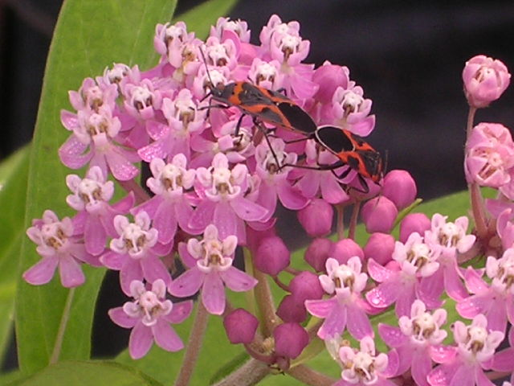
Swamp Milkweed
Height: 30 – 150 cm
Blooms: June – August
Light: Full Sun
Soil: All
Moisture: Moist, Wet
Larval host for: Monarch and Queen butterfly
Attracts: Butterflies, Butterfly larvae, Bees, Hummingbirds
(Evergreen’s Native Plant Database)
Joe Pye Weed
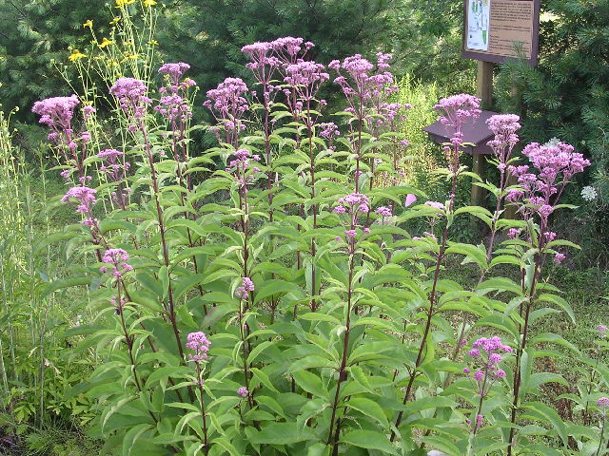
Height: 60 – 180 cm
Blooms: August – September
Light: Full Sun, Partial Shade
Soil: All
Moisture: Normal, Moist, Wet
Attracts: Butterflies, Bees, Birds
(Evergreen’s Native Plant Database)
Images from Acorus Restoration

Swamp Milkweed and Joe Pye Weed are found within Peel Region and are native to the Credit River Watershed (Credit Valley Conservation, 2002).
Goals and Objectives
The goal of this project is to enhance naturalized site #15 in a way that provides food and shelter for more wildlife, including the monarch butterfly, while engaging students in environmental stewardship. In order to achieve this goal, we seek to accomplish the following objectives:
  - Planting of native plant species which attract butterflies and creates a more enriched habitat at naturalized site #15.
  - Placing an informational sign on the site which describes the ecosystem, including the types of plant species and wildlife found on the site.
  - Ensuring long-term maintenance of the site through Campus Roots.

Methods

Approval for this habitat enhancement project will be sought from the UTM Naturalization Steering Committee. Once approval is granted, project coordinators will proceed by arranging and purchasing all necessary supplies for the planting event. The following is a list of the supplies required and how each item will be obtained:

- Gardening gloves: provided by Campus Roots
- Shovels: a request will be sent to the Grounds Department
- Swamp Milkweed and Joe Pye Weed: to be purchased from Acorus Restoration
- Mulch and buckets: a request will be sent to the Grounds Department
- Informational signage: to be purchased by the project coordinators
- Food and refreshments: to be purchased by the project coordinators

UTM NDP and Campus Roots will be responsible for recruiting volunteers for the planting event. The event will be publicized in advance through mass emails and event invitations which describe the project and requests volunteers. Those who wish to participate will be given any necessary information beforehand, such as proper attire for the event and when and where to meet. A reminder email will also be sent out prior to the date of the event.

On the day of the event, project coordinators will arrive early to set up the supplies on site and layout the potted plants according to where they are to be planted. This will ensure better organization and use of volunteer time. At the beginning of the event, volunteers will be shown a demonstration of proper planting procedures and safety tips before proceeding. Healthy food and refreshments will also be provided to volunteers during the event.

On a date following the planting event, an informational sign will be placed on the site which describes the existing species and its ecological importance. Campus Roots will also ensure future maintenance of the site by conducting stewardship activities such as litter clean-up and invasive species removal. It is the club’s mandate to carry-out environmental stewardship on campus and maintain the naturalized sites on campus.

A description for each project activity with a timeline is outlined in the Project Workplan ( see page 6).

Budget

UTM NDP has allocated $500.00 towards this project. The expenditure amounts are based on estimates.

Funding | UTM NDP | $500.00
Expenses | Swamp Milkweed, 35 pots @ $3.70/pot | $129.50
 | Joe Pye Weed, 35 pots @ $3.70/pot | $129.50
 | Informational Signage | $150.00
 | Food and Refreshments | $25.00
 | Total Expenses | $434.00

Project Contacts

Andrew Hamilton-Smith, President UTM NDP

Angie Sanchez, Co-President Campus Roots

Ester Wachnik, Co-President Campus Roots
Project Map

Map of the University of Toronto Mississauga
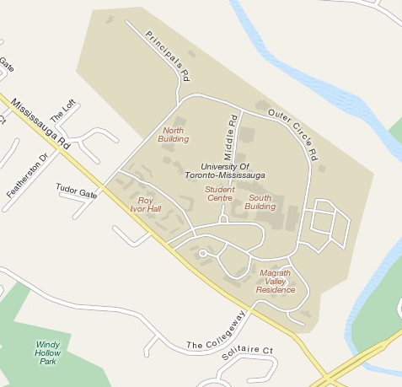

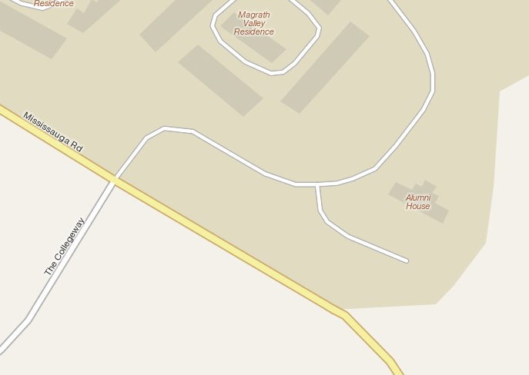
Naturalized Site #15 (dry pond) and proposed site for monarch butterfly habitat enhancement project

Project Workplan

Dates of completion are approximations.

Project Activity | Description | Date of Completion | Task Assignment
Project Approval | Gain project approval from the UTM Naturalization Steering Committee to proceed with the project. | Early May 2010 | Presidents of UTM NDP and Campus Roots
Order Plants | Order native plant species (Swamp Milkweed and Joe Pye Weed) from Acorus Restoration. | Mid May 2010  (May 13) | Co-Presidents, Campus Roots
Request Supplies | Contact the Grounds Department and request/arrange shovels and mulch for the day of the event. | Mid May 2010  (May 13) | Co-Presidents, Campus Roots
Recruit Volunteers | Send out mass emails and event invitation to all club members, promoting the project and requesting volunteers. Volunteers are to RSVP by May 23rd. | Mid May 2010  (May 17) | VP Volunteers and VP Outreach, Campus Roots and UTM NDP
Confirm Supplies | Ensure that all supplies needed are secured for the planting event. | Late May  (May 24) | Co-Presidents, Campus Roots
Reminder Email | Send out a reminder email to all volunteers the day before the event, confirming meeting time and location. | Late May 2010  (May 26) | VP Volunteers and VP Outreach, Campus Roots and UTM NDP
Food and Refreshments | Purchase the necessary amount of food and refreshments needed for volunteers. Food and refreshments should produce little to minimal waste (i.e. apples, re-usable/biodegradable cups). | Late May 2010  (May 26) | President, UTM NDP
Planting Event | Carrying-out the project. Properly set-up and organize all supplies and volunteers so that the event runs smoothly. Conduct a demonstration beforehand so that volunteers are clear on proper planting methods. | Late May 2010  (May 27) | UTM NDP, Campus Roots, and all recruited volunteers
Designing Informational Sign | Designing an informational sign which will be placed on the site. The sign will describe the various plant species and wildlife that can be found on the site, as well as its ecological importance. | July 2010 | VP Marketing and VP Outreach, Campus Roots
Ordering Informational Sign | Contacting different signage makers and finding the most competitive price. | August 2010 | Presidents of UTM NDP and Campus Roots
Maintenance of Site | Conducting stewardship activities, such as litter clean-up and invasive species removal on the naturalized site. | Ongoing | Campus Roots
References

Acorus Restoration. https://www.ecologyart.com/index.php (accessed April 27, 2010).

Credit Valley Conservation. 2002. “Plants of the Credit River Watershed.” http://www.creditvalleycons.com/programsandservices/downloads/PlantsComplete.pdf (accessed April 27, 2010).

Credit Valley Conservation. 2009. “Credit Valley Conservations Tree Planting Service: Site Evaluation Factsheet.” http://www.creditvalleycons.com/programsandservices/downloads/treeplanting/4-SiteEvaluation-web.pdf (accessed April 27, 2010).

Evergreen. “Native Plant Database.” http://nativeplants.evergreen.ca/ (accessed April 27, 2010).

North American Native Plant Society and Rouge Park. 1999. “Butterfly Gardening: Attracting Butterflies to Gardens in the Great Lakes Watershed.” North American Native Plant Society. http://www.nanps.org/pdfs/butterfact.pdf (accessed April 27, 2010).

